# Supplementary Figures

## Supplementary Figure 1

*Supplementary Figure 1: Empirical Cumulative Density Function of the home range radius of rodent and shrew species with data available in the HomeRange dataset. Species that match detected genera in our study include two shrew species Crocidura leucodon and Crocidura shantungensis and two rodent species Hylomyscus stella and Praomys tullbergi. Four species matches to rodent species detected in our study were also included Lemniscomys striatus, Mastomys natalensis, Mus musculus and Rattus rattus. Only Lemniscomys striatus and Mastomys natalensis contain data from Africa (Uganda and Tanzania respectively). The dashed line represents the 30m range radius used for the primary analysis in the current study.*

## Supplementary Figure 2

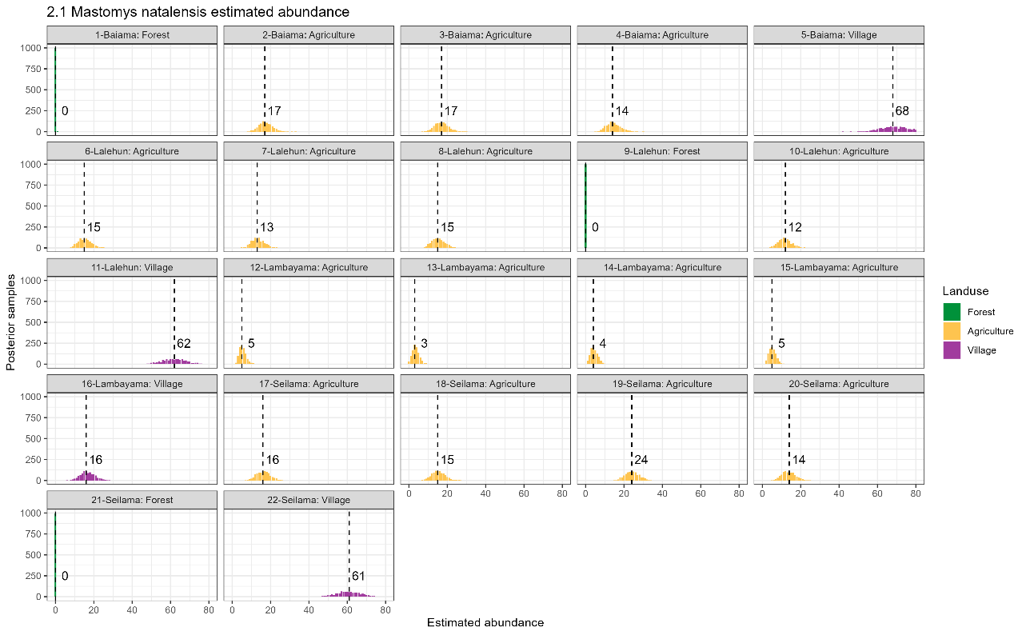

*Supplementary Figure 2.1: Estimated abundance at each sampling site for Mastomys natalensis. The dashed line and number is the median abundance used to infer the population size at this study site.*

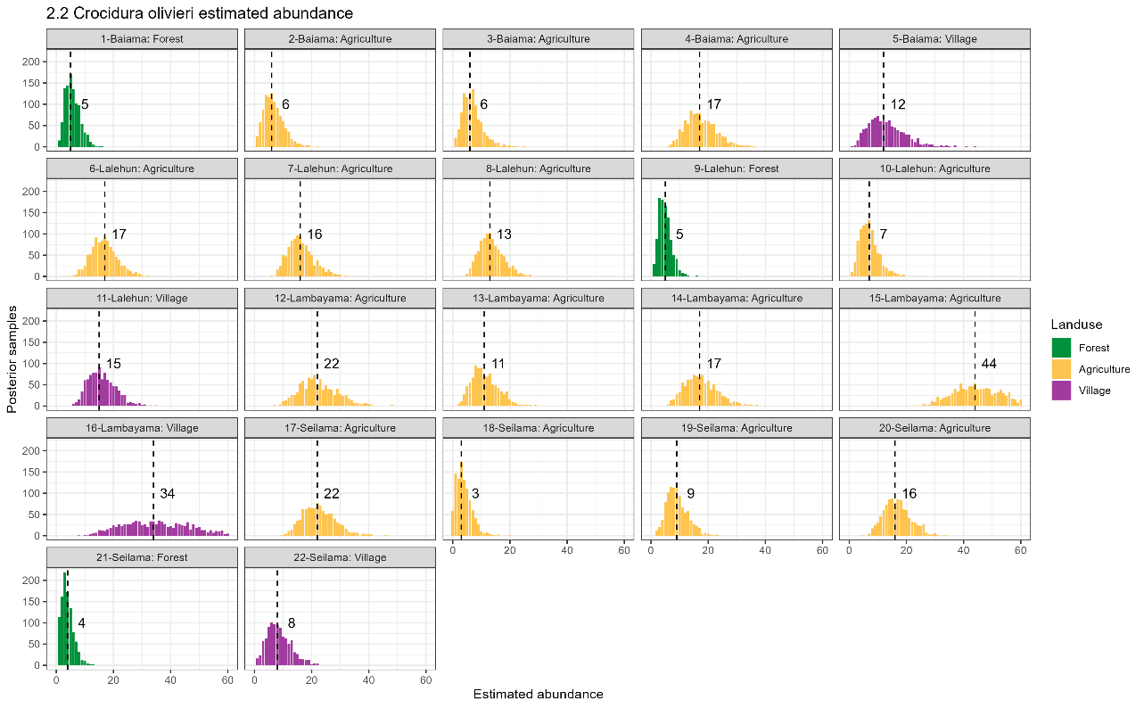

*Supplementary Figure 2.2: Estimated abundance at each sampling site for Crocidura olivieri. The dashed line and number is the median abundance used to infer the population size at this study site.*

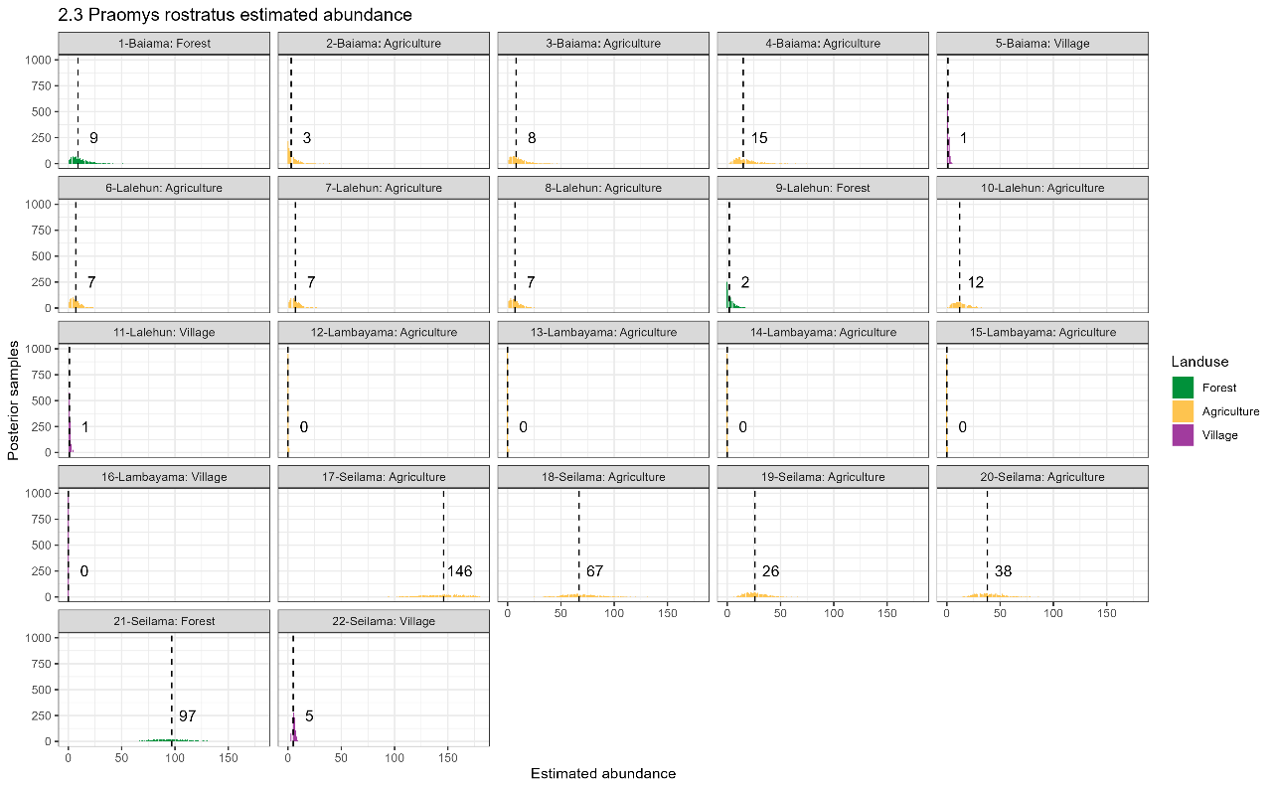

*Supplementary Figure 2,3: Estimated abundance at each sampling site for Praomys rostratus. The dashed line and number is the median abundance used to infer the population size at this study site.*

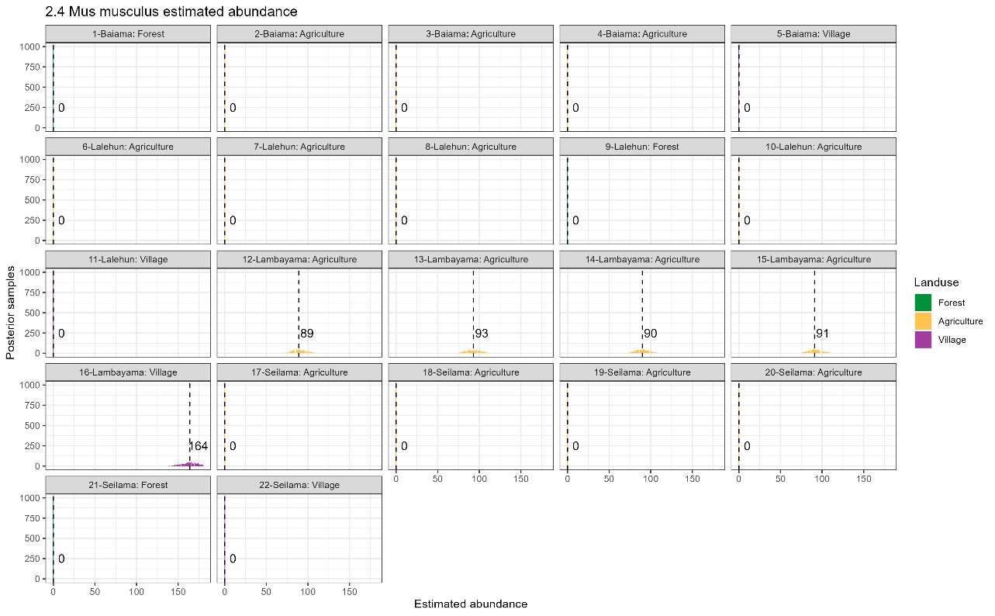

*Supplementary Figure 2.4: Estimated abundance at each sampling site for Mus musculus. The dashed line and number is the median abundance used to infer the population size at this study site.*

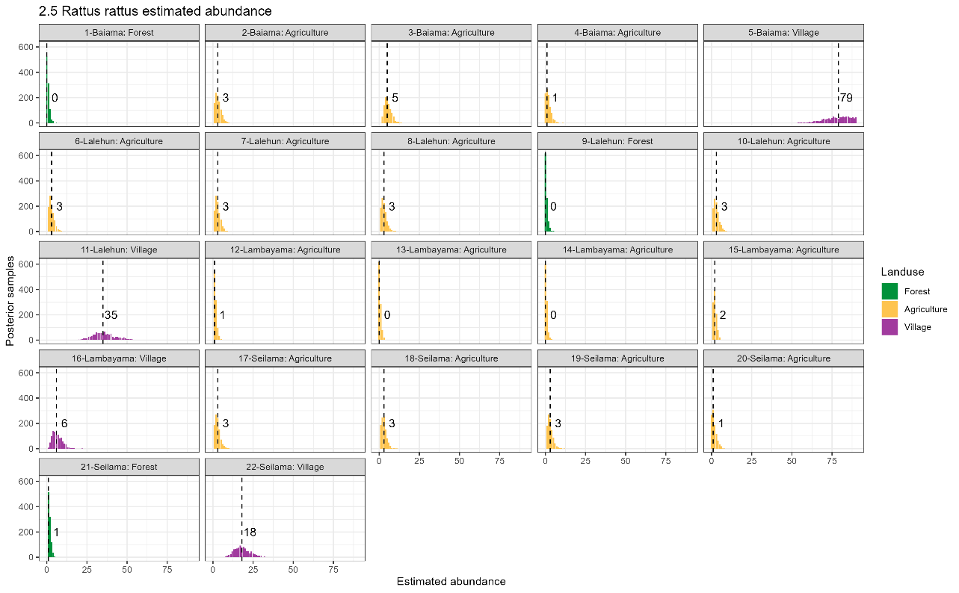

*Supplementary Figure 2.5: Estimated abundance at each sampling site for Rattus rattus. The dashed line and number is the median abundance used to infer the population size at this study site.*

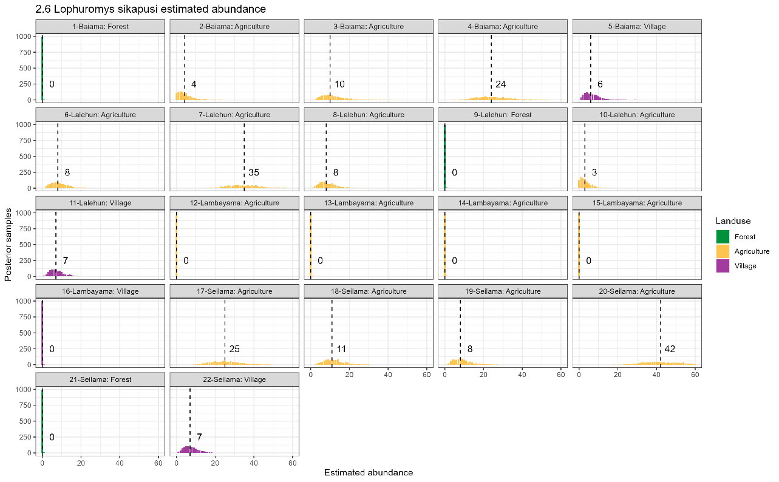

*Supplementary Figure 2.6: Estimated abundance at each sampling site for Lophuromys sikapusi. The dashed line and number is the median abundance used to infer the population size at this study site.*

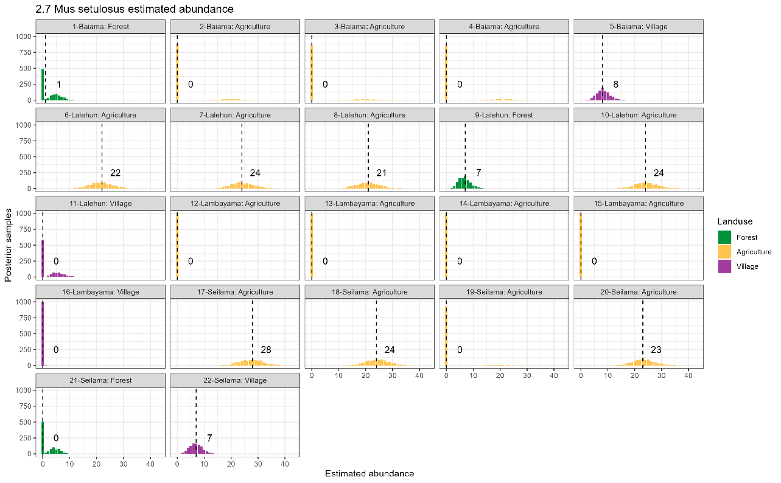

*Supplementary Figure 2.7: Estimated abundance at each sampling site for Mus setulosus. The dashed line and number is the median abundance used to infer the population size at this study site.*

*Supplementary Figure 2.8: Estimated abundance at each sampling site for Crocidura buettikoferi. The dashed line and number is the median abundance used to infer the population size at this study site.*

*Supplementary Figure 2.9: Estimated abundance at each sampling site for Crocidura grandiceps. The dashed line and number is the median abundance used to infer the population size at this study site.*

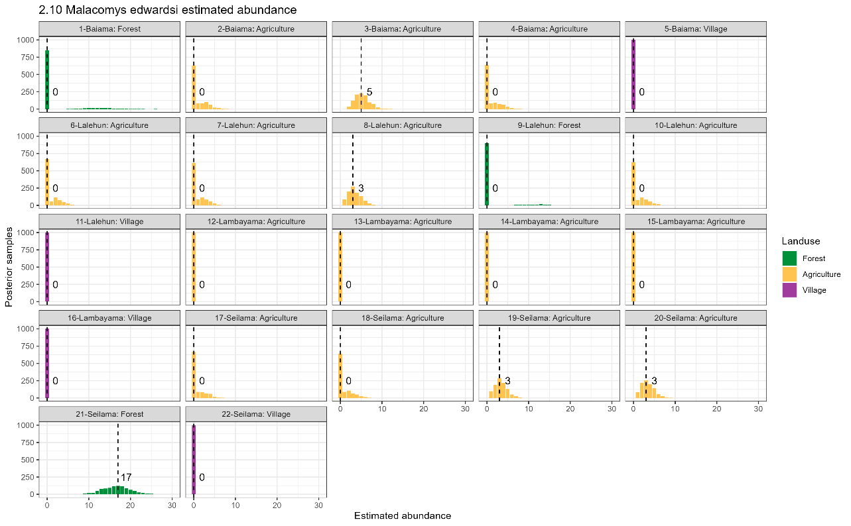

*Supplementary Figure 2.10: Estimated abundance at each sampling site for Malacomys edwardsi. The dashed line and number is the median abundance used to infer the population size at this study site.*

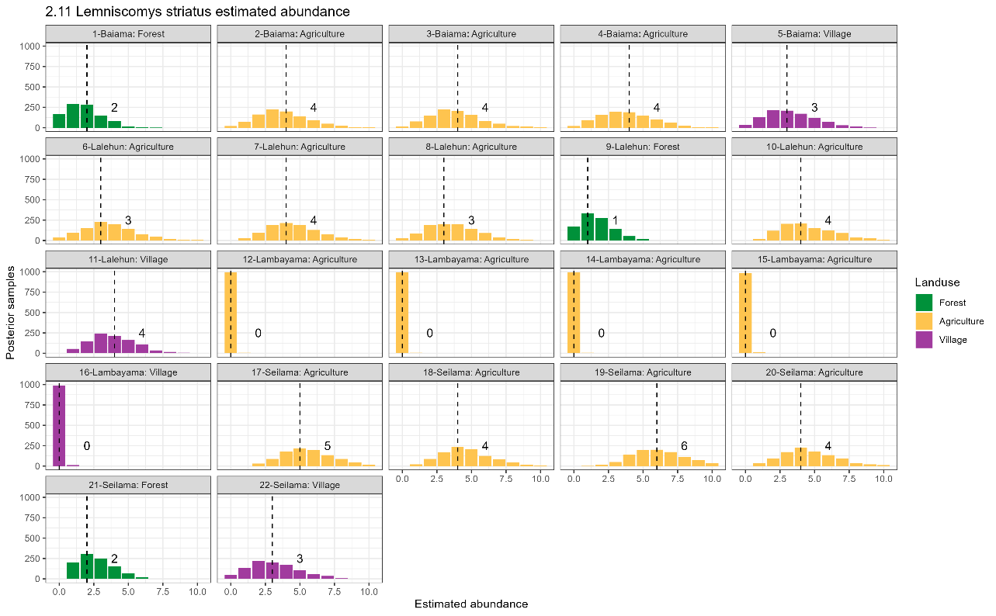

*Supplementary Figure 2.11: Estimated abundance at each sampling site for Lemniscomys striatus. The dashed line and number is the median abundance used to infer the population size at this study site.*

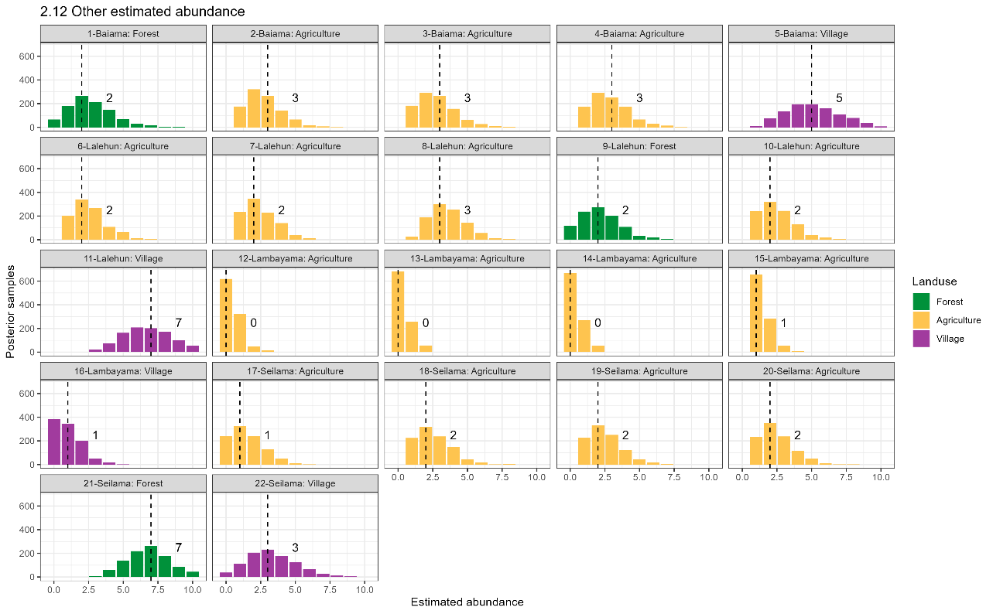

*Supplementary Figure 2.12: Estimated abundance at each sampling site for Other species. The dashed line and number is the median abundance used to infer the population size at this study site.*

## Supplementary Figure 3

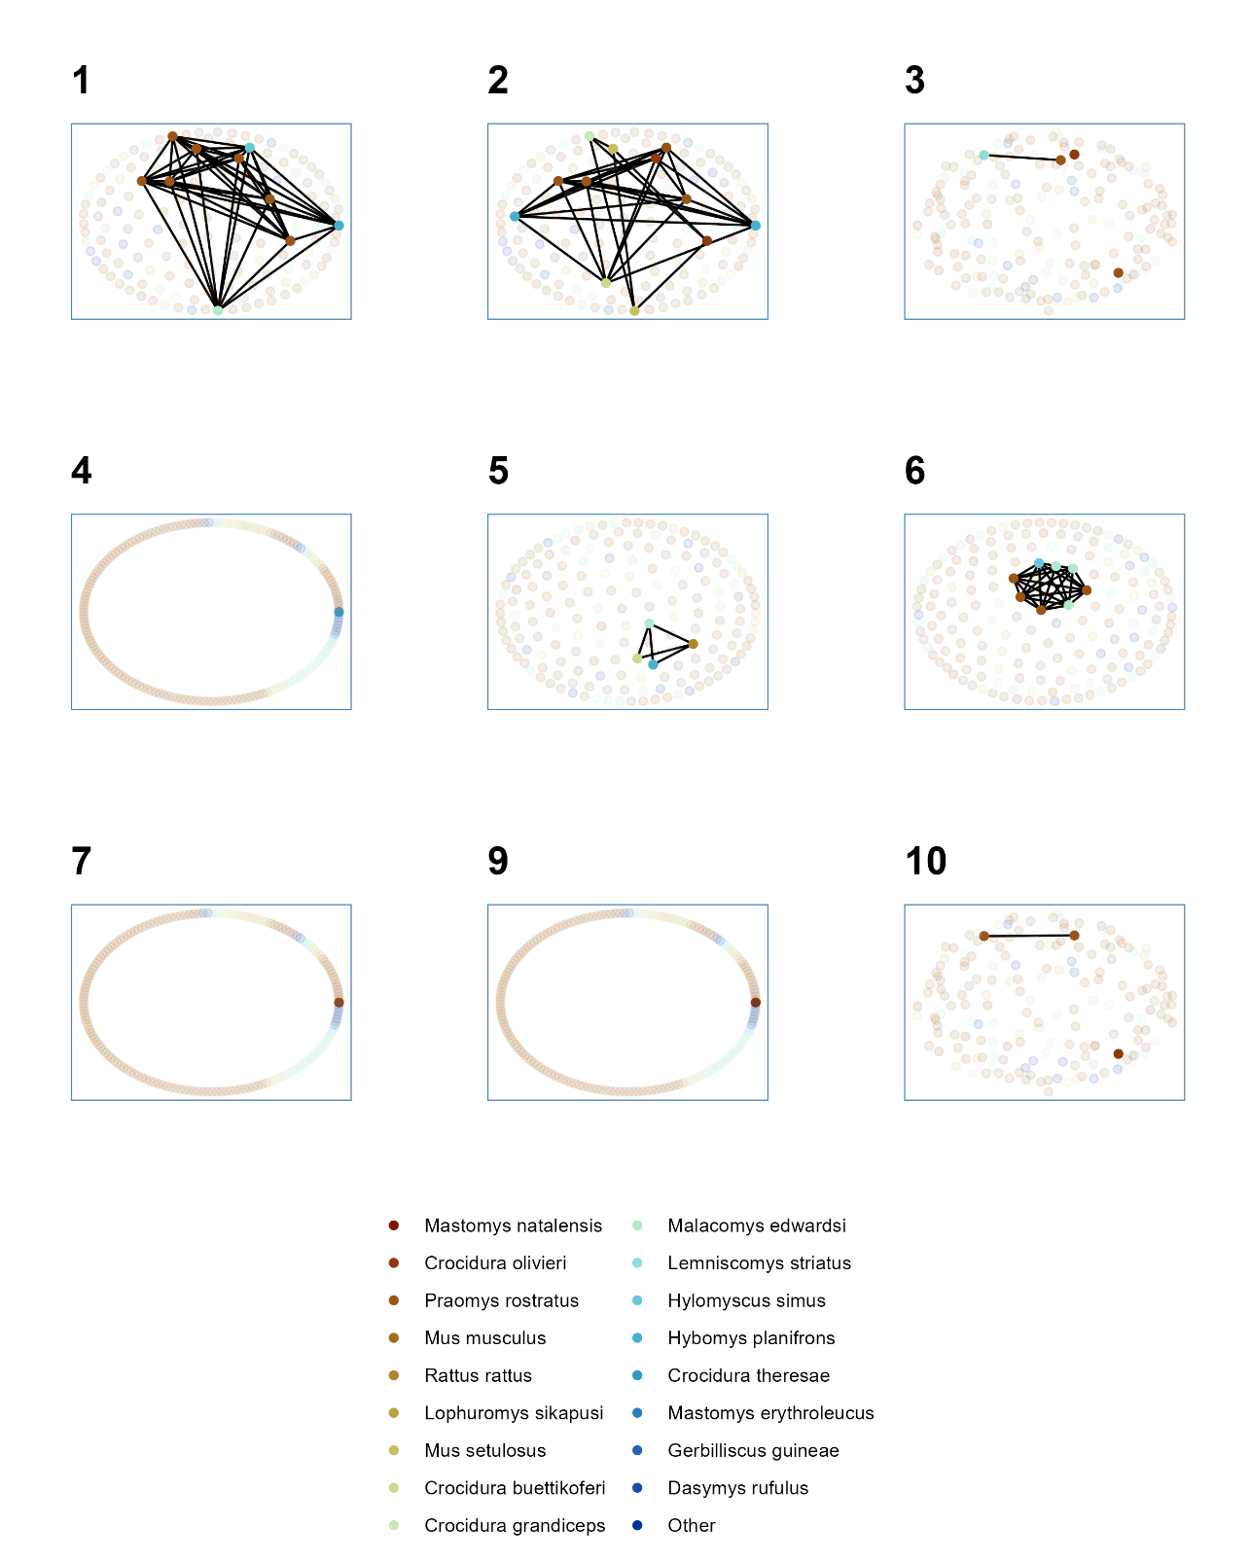

*Supplementary Figure 3.1: Networks produced from trapping sessions conducted in forest settings. Numbers refer to the trapping session, no individuals were detected in forest during trapping session 8. Observed individuals are shown in solid colours with colour referring to species. Unobserved individuals estimated from abundance modelling are shown in pale colours. Contacts between individuals (edges) are shown for observed individuals only.*

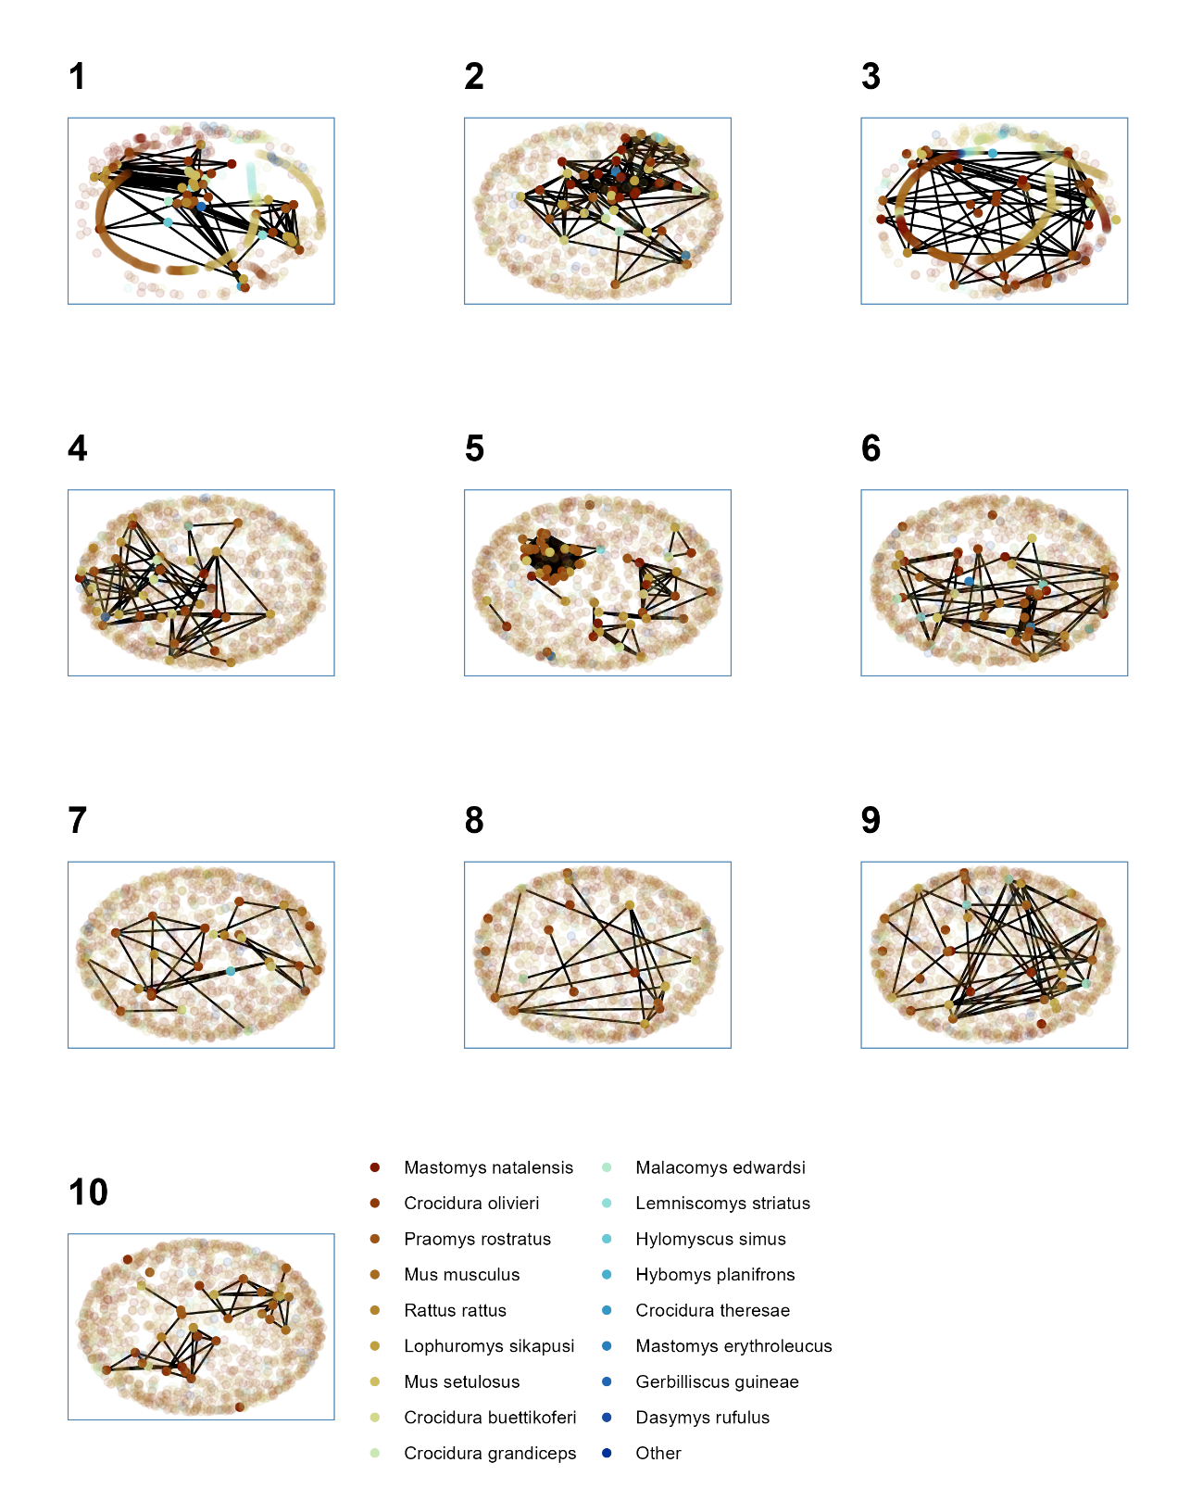

*Supplementary Figure 3.2: Networks produced from trapping sessions conducted in agricultural settings. Numbers refer to the trapping session. Observed individuals are shown in solid colours with colour referring to species. Unobserved individuals estimated from abundance modelling are shown in pale colours. Contacts between individuals (edges) are shown for observed individuals only.*

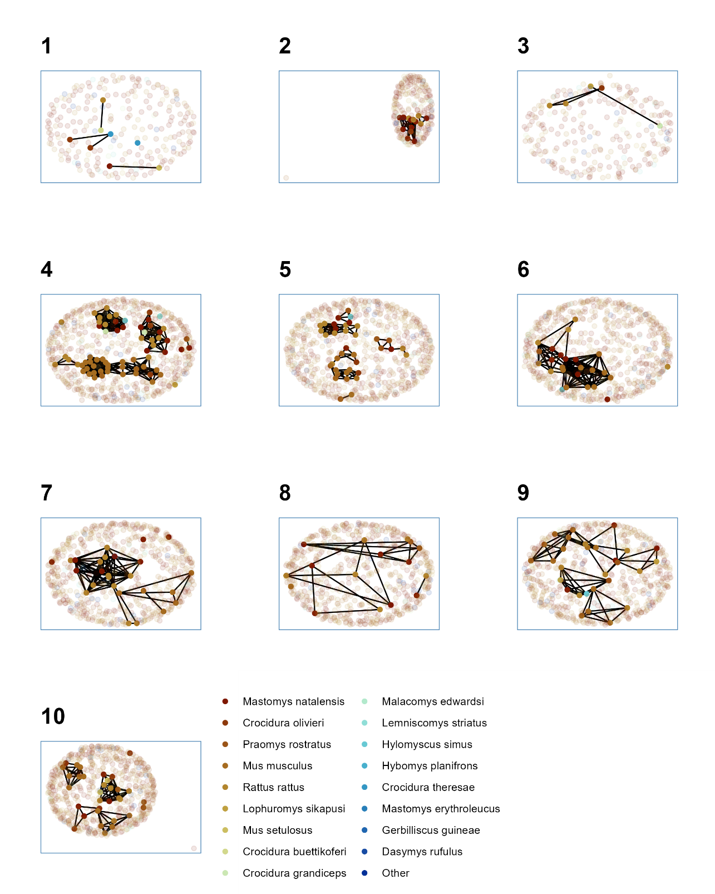

*Supplementary Figure 3.3: Networks produced from trapping sessions conducted in village settings. Numbers refer to the trapping session. Observed individuals are shown in solid colours with colour referring to species. Unobserved individuals estimated from abundance modelling are shown in pale colours. Contacts between individuals (edges) are shown for observed individuals only.*

## Supplementary Figure 4

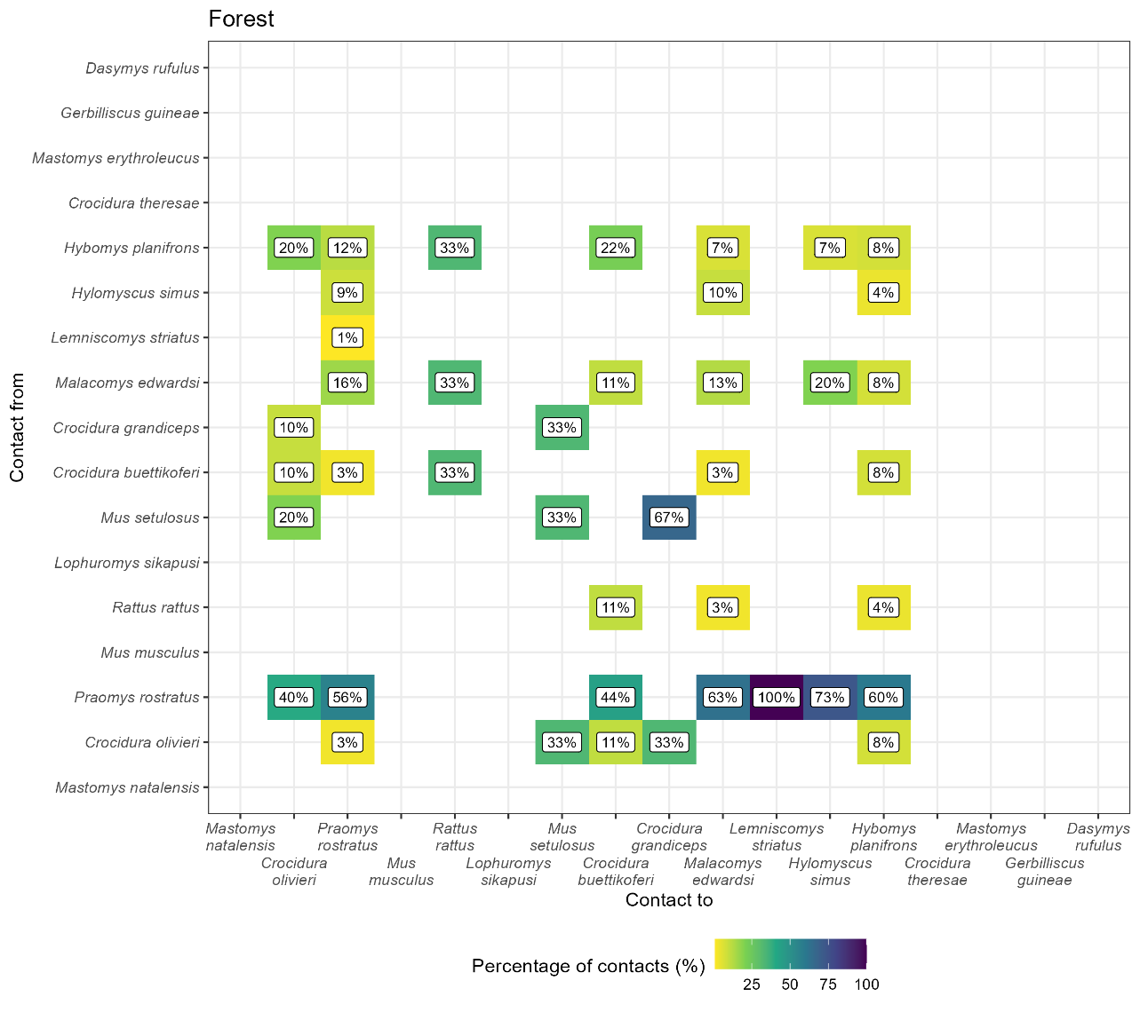

*Supplementary Figure 4.1: The proportion of contacts between individual small mammals in forest land use. Darker colours indicate increasing proportions of observed contacts to a species (Contact to) from named species (Contact from). Numbers in the cells correspond to the proportion of contacts to a species from a named species. For example, 56% of all contacts to Praomys rostratus are from other P. rostratus while 16% of contacts are from Malacomys edwardsi. Percentages sum to 100% in the Contact to axis, while they may exceed 100% in Contact from. Species are ordered by the total number detected in this study.*

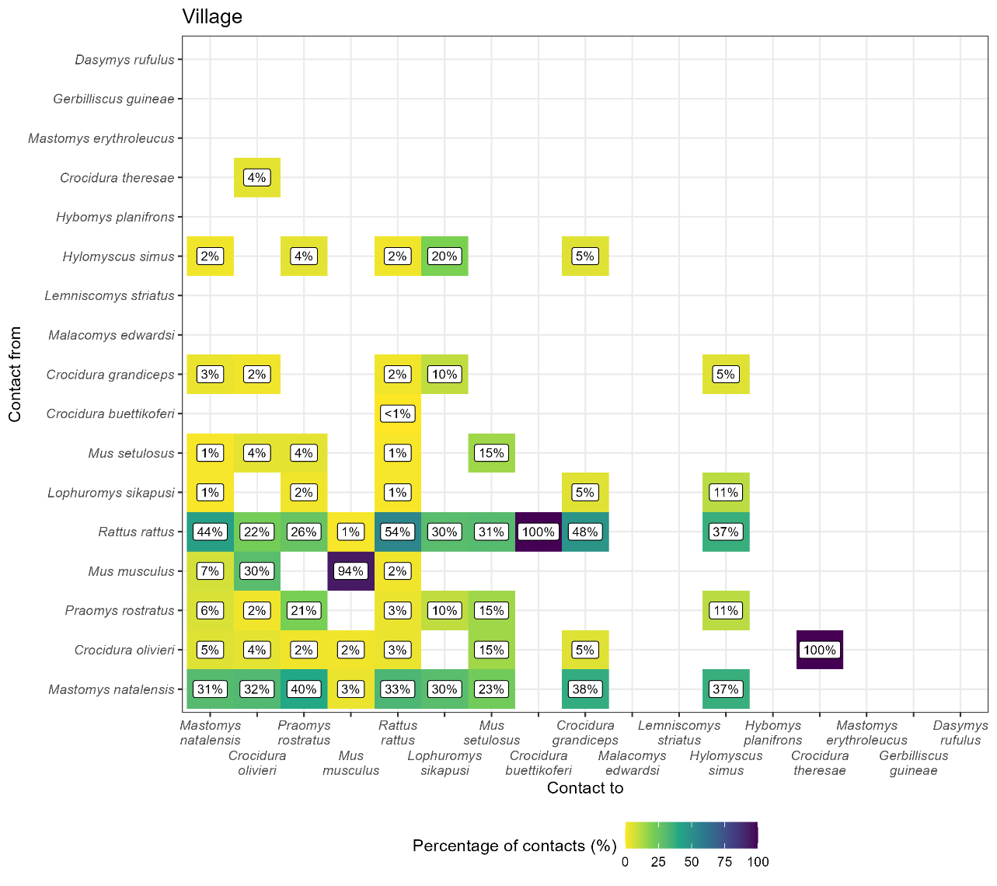

*Supplementary Figure 4.2: The proportion of contacts between individual small mammals in village land use. Darker colours indicate increasing proportions of observed contacts to a species (Contact to) from named species (Contact from). Numbers in the cells correspond to the proportion of contacts to a species from a named species. For example, 31% of all contacts to Mastomys natalensis are from other M. natalensis while 44% of contacts are from Rattus rattus. Percentages sum to 100% in the Contact to axis, while they may exceed 100% in Contact from. Species are ordered by the total number detected in this study.*

## Supplementary Figure 5

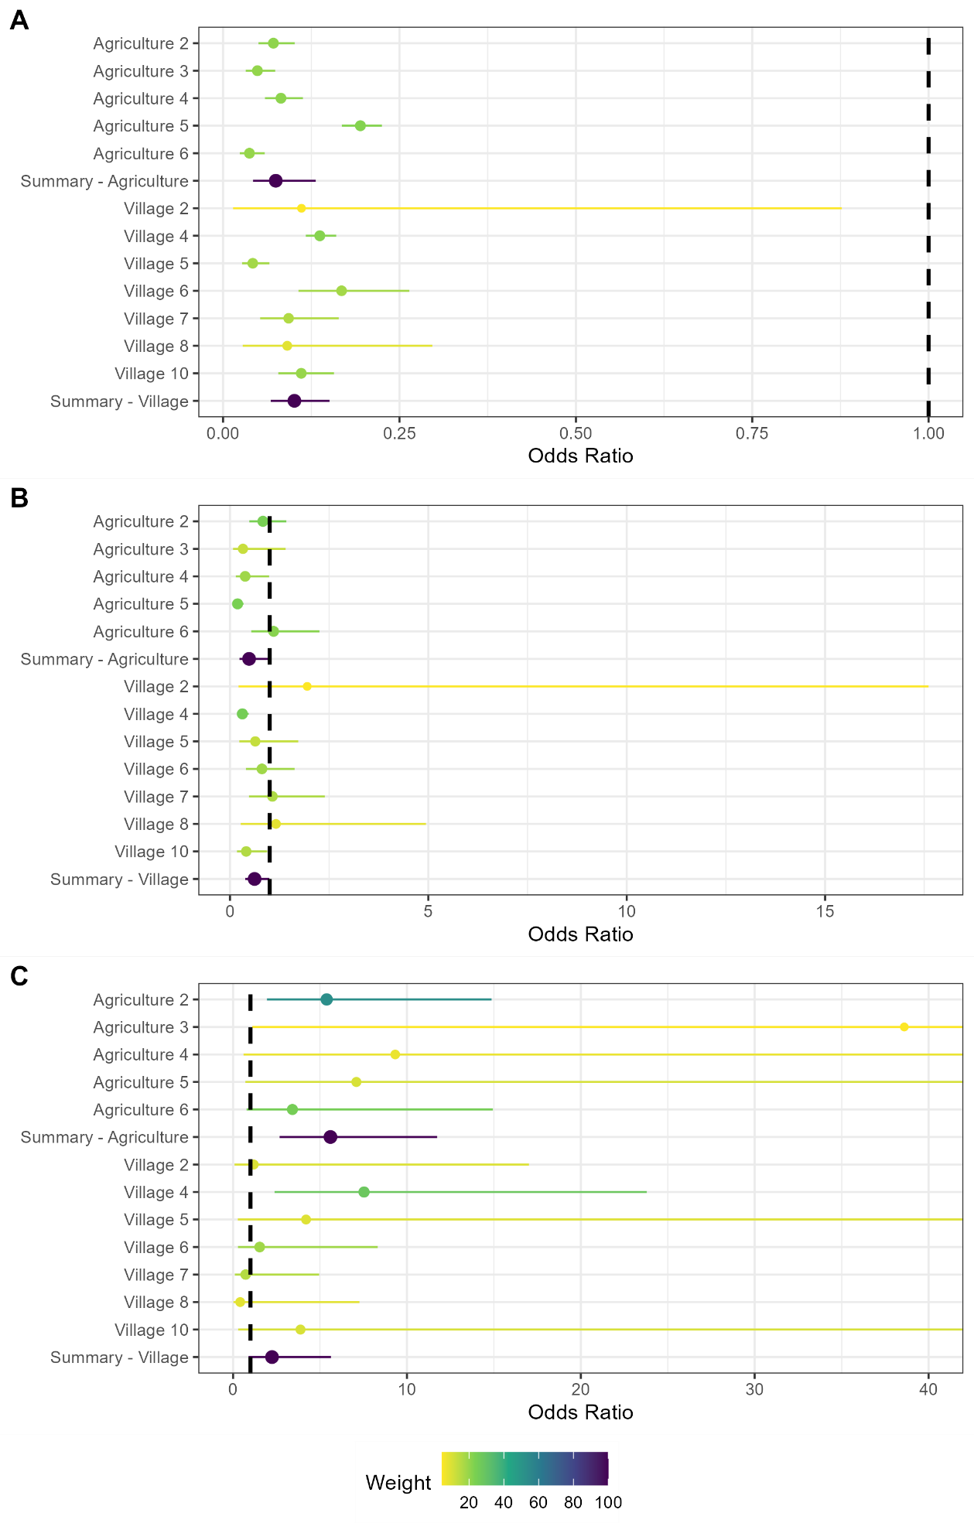

*Supplementary Figure 5.1: Random effects meta-analysis of ERGM network models reporting the odds of a contact being observed for M natalensis for the first sensitivity analysis by changing the buffer radius to 15m. A) The odds ratio of a contact being observed for M. natalensis in Agricultural or Village land use types. The finding of reduced odds of an observed edge is consistent with the main analysis (buffer radius = 30m). B) The odds ratio of a contact being observed between M. natalensis and an individual of a different rodent species. The finding of reduced odds of an interspecific edge is consistent with the main analysis. C) The odds ratio of a contact being observed between M. natalensis and another M. natalensis. This finding of increased odds of observing an intraspecific contact is consistent with the main analysis.*

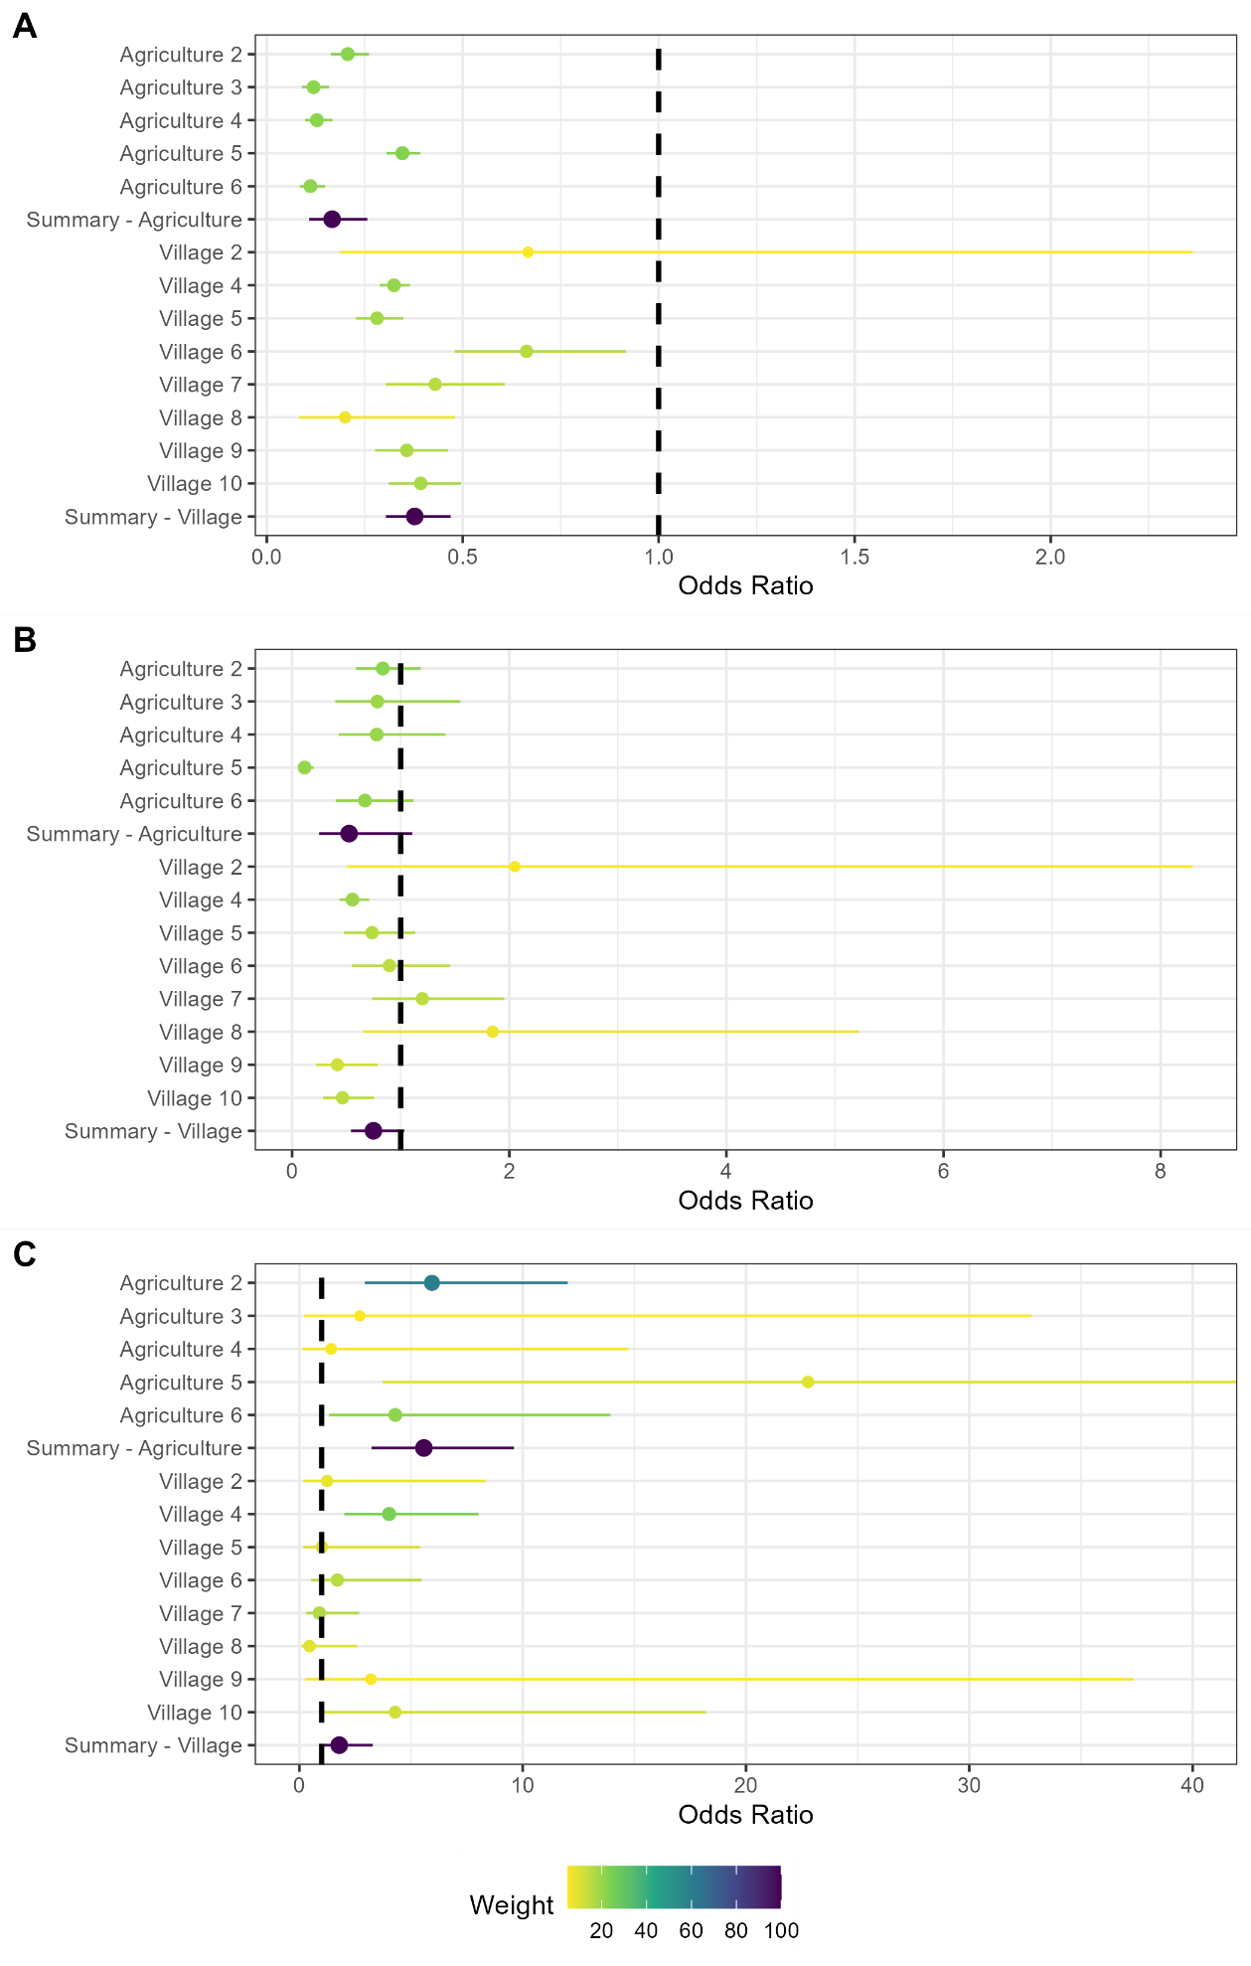

*Supplementary Figure 5.2: Random effects meta-analysis of ERGM network models reporting the odds of a contact being observed for M natalensis for the second sensitivity analysis by changing the buffer radius to 50m. A) The odds ratio of a contact being observed for M. natalensis in Agricultural or Village land use types. The finding of reduced odds of an observed edge is consistent with the main analysis (buffer radius = 30m). B) The odds ratio of a contact being observed between M. natalensis and an individual of a different rodent species. The finding of reduced odds of an interspecific edge is consistent with the main analysis. C) The odds ratio of a contact being observed between M. natalensis and another* *M. natalensis. This finding of increased odds of observing an intraspecific contact is consistent with the main analysis.*